ELK Stack – Elastic Search, Logstash, Kibana
1. What is the ELK Stack?
The ELK Stack is a popular open-source platform designed for real-time log management, analysis, and visualization. It is a collection of three distinct but integrated projects:
- E → Elasticsearch: A distributed, RESTful search and analytics engine. It acts as the central datastore.
- L → Logstash: A server-side data processing pipeline that ingests data from various sources, transforms it, and sends it to a "stash," like Elasticsearch.
- K → Kibana: A web interface that allows users to visualize, explore, and analyze the data stored in Elasticsearch through charts, graphs, and dashboards.
Today, the stack has evolved and is more accurately called the Elastic Stack, which includes an additional component:
- Beats: A family of lightweight, single-purpose data shippers that send data from hundreds or thousands of machines to Logstash or Elasticsearch.
2. Why is the ELK Stack Used? (The Problem It Solves)
In modern distributed systems, applications and infrastructure components are spread across many servers, containers, and cloud services. Each component generates logs, creating a massive, decentralized flood of data. Before a solution like ELK, troubleshooting or analyzing system-wide behavior was a nightmare. The core problems ELK solves are:
- Log Consolidation: It provides a centralized platform to collect and store logs from all sources, eliminating the need to SSH into individual machines.
- Lack of Searchability: It makes petabytes of log data instantly searchable, allowing engineers to find a needle in a haystack in milliseconds.
- Difficult Correlation: It allows users to correlate events across different services and timeframes to understand the full context of an issue.
- No Real-time Visibility: It provides real-time dashboards and alerts, enabling proactive monitoring rather than reactive problem-solving.
3. How Does the ELK Stack Work? (The Architecture & Data Flow)
The ELK Stack operates as a data pipeline. Each component plays a specific role in the end-to-end flow of data.
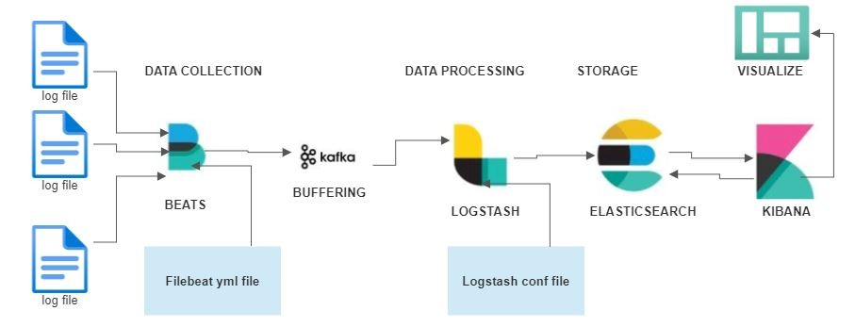

The Components:
- Beats (The Collectors): These are lightweight agents installed on source machines (e.g., web servers, database servers). Filebeat tails log files, Metricbeat collects system metrics (CPU, RAM), and Packetbeat monitors network traffic. They are efficient and have a low footprint.
- Logstash (The Processor): While Beats can send data directly to Elasticsearch, Logstash is used for more complex processing. It receives data from Beats, applies filters to parse and enrich it (e.g., extracting an IP address and using it to look up the geographic location), and then forwards the clean, structured data.
- Elasticsearch (The Store & Index): This is the heart of the stack. It stores the JSON documents sent by Logstash. It uses a powerful data structure called an "inverted index" to analyze and search data with incredible speed. It is horizontally scalable, meaning you can add more nodes to handle more data.
- Kibana (The Visualizer): This is the user's window into the data. Kibana connects to the Elasticsearch API to run queries and render the results. Users can create interactive dashboards, generate reports, and set up alerts without writing complex code.
End-to-End Data Flow: [Data Source] -> Beats -> Logstash (Optional) -> Elasticsearch -> Kibana -> [User]
- A web server generates a new log entry.
- Filebeat, running on the server, detects the new entry and sends it to Logstash.
- Logstash parses the log, extracts key fields, and converts it to a structured JSON format.
- Logstash sends the JSON document to Elasticsearch.
- Elasticsearch indexes the document, making it searchable.
- A developer viewing a Kibana dashboard sees the error count spike in real-time.
4. Major Advantages and Limitations
Advantages:
- Open Source: The core stack is free to use, fostering a large community and extensive documentation.
- Real-Time Capability: Data is available for search and analysis within seconds of being generated.
- Scalability: Elasticsearch is built to be distributed. You can start with a single node and scale to hundreds to handle massive data volumes.
- Flexibility: It can ingest and process any type of text-based data, not just logs (e.g., metrics, application traces, documents).
- Powerful Visualization: Kibana offers a rich set of tools for creating insightful and interactive dashboards.
Limitations:
- Operational Complexity: Managing a large, production-grade ELK cluster requires significant expertise. Sizing, scaling, and upgrading can be complex.
- Resource Intensive: Elasticsearch, in particular, can be demanding on RAM and CPU, leading to high infrastructure costs.
- Steep Learning Curve: While basic setup is straightforward, mastering the query DSL (Domain Specific Language) and advanced configurations takes time.
- Commercial Features: Critical features for enterprise use, such as advanced security, alerting, and machine learning, are part of a paid subscription (X-Pack).
5. Benefits for the Business
- Reduced Downtime: By enabling faster root cause analysis, businesses can resolve production issues much quicker, minimizing revenue loss and impact on customers.
- Improved Customer Experience: Proactive monitoring helps identify performance bottlenecks and potential issues before they affect users, leading to a more reliable service.
- Enhanced Security Posture: ELK is widely used as a Security Information and Event Management (SIEM) tool to detect and respond to security threats in real-time by analyzing security and access logs.
- Data-Driven Decisions: By analyzing user activity logs, businesses can gain insights into feature usage, user behavior, and conversion funnels, informing product and business strategy.
6. Impacts of Implementation
Implementing the ELK Stack often has the following impacts on an organization:
- Fosters a DevOps Culture: It provides a shared platform where Developers (Dev) and Operations (Ops) can view the same data, leading to better collaboration and faster problem resolution.
- Shifts from Reactive to Proactive Monitoring: Teams move from waiting for failure alerts to actively monitoring system health and predicting potential issues.
- Empowers Engineers: It gives engineers direct access to logs and metrics, reducing their dependency on specialized teams and empowering them to troubleshoot their own applications.
7. How it is Useful/Related to Data Engineering & Databricks
The ELK Stack is highly relevant to the field of data engineering and serves as a complementary tool to platforms like Databricks.
1. Monitoring Data Pipelines: Data engineers build and manage complex data pipelines. The ELK Stack is the perfect tool to monitor these pipelines. For example, the logs generated by Spark jobs, Airflow DAGs, or Kafka streams can be ingested into ELK. This allows data engineers to:
- Debug Failed Jobs: Quickly search through all Spark executor logs in one place to find the root cause of a failed Databricks job.
- Monitor Performance: Create dashboards to track job run times, data processing volumes, and resource utilization (CPU/memory) of Databricks clusters.
- Audit and Governance: Analyze Databricks audit logs to monitor who is accessing what data and what queries are being run.
2. ELK as a Serving Layer for Databricks Output: This is a powerful architectural pattern. Databricks is excellent for large-scale, complex data processing and transformation, but it is not a low-latency serving database. Elasticsearch is.
- The Workflow:
  - Ingest & Process: Raw data (from a data lake like S3 or ADLS) is processed, cleaned, and aggregated in Databricks using Spark.
  - Load to Elasticsearch: The final, processed data from the Databricks job is written directly into an Elasticsearch index.
  - Serve & Visualize: The data is now available in Elasticsearch for fast, interactive querying and can be visualized in Kibana.
- Example Use Case: A company analyzes billions of e-commerce transaction records in Databricks to calculate daily sales trends and product popularity. The aggregated results (a much smaller dataset) are written to Elasticsearch. The business team can then use a Kibana dashboard to instantly explore sales data by region, product, or time of day without having to run a slow query on the massive raw dataset.

